Spring MVC CURD operations

**Jars needed: -**

* Spring core
* Spring web
* Ojdbc14.jar for oracle (or) mysql-connector.jar for mysql

**Classes needed: -**

* Model class with required fields
* DAO that will have methods to interact with DB
* Controller class that will have methods to address the requests

**Other files needed: -**

* Web.xml file (Application configuration file)
* servlet _name-servlet.xml (Bean configuration file)
* View files

1. First create a **Dynamic web project**

**File->new->Dynamic web project**

Give project name and click next, in next screen click next again.

In next screen check the box generate web.xml and click finish.

Refer the below image for project structure

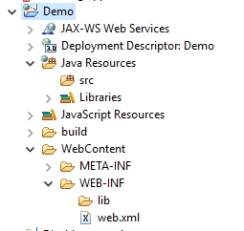

Add all the above mentioned jars in

**WebContent->WEB-INF->lib (**copy and paste the required jars in lib folder)

1. Create a package **com.employee.beans** in **Java Resources - > src** folder

Create a class **Employee** with required fields as below in above created package

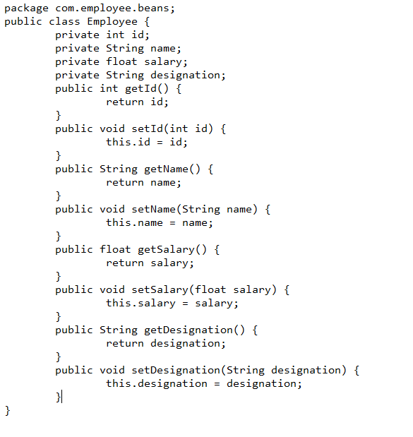

1. Create another package **com.employee.dao** in **Java Resources - > src** folder

Create a class **EmployeeDao** with required fields as below in above created package

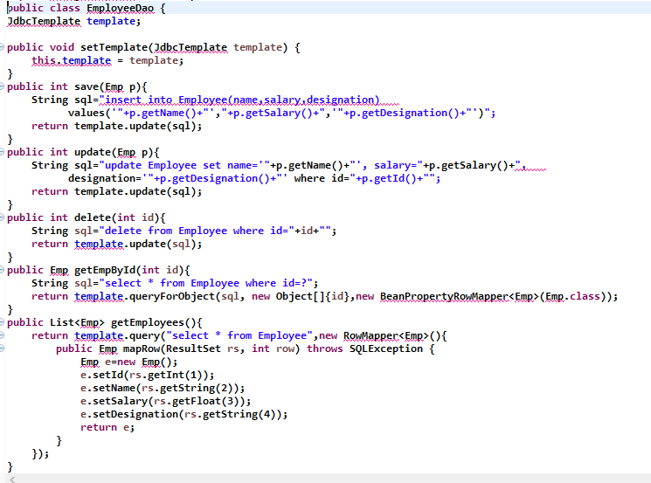

1. Create another package **com.employee.controller** in **Java Resources - > src** folder

Create a class **EmployeeController** with required fields as below in above created package

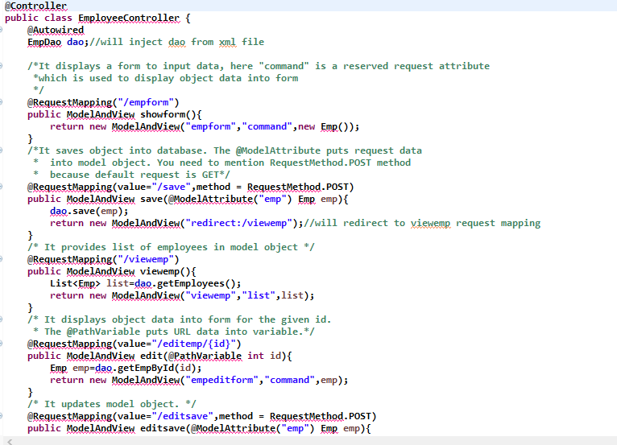

1. Edit **web.xml** file in **WebContent->WEB-INF** folder

Add the below code for dispatcher servlet in web.xml file below **welcome-file-list**

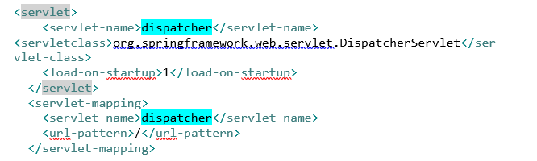

Now we have configured dispatcher servlet for our application. All the URL’s with “/” pattern will go to dispatcher servlet first.

1. Create an xml file in **WebContent->WEB-INF** with **servlet_name-servlet.xml,** here **servlet_name** is the name of the servlet that has been highlighted in above web.xml file.

So our file name should be **dispatcher-servlet.xml**

In this file we will specify all beans that we want like datasource, viewresolvers , hibernate configurations etc.

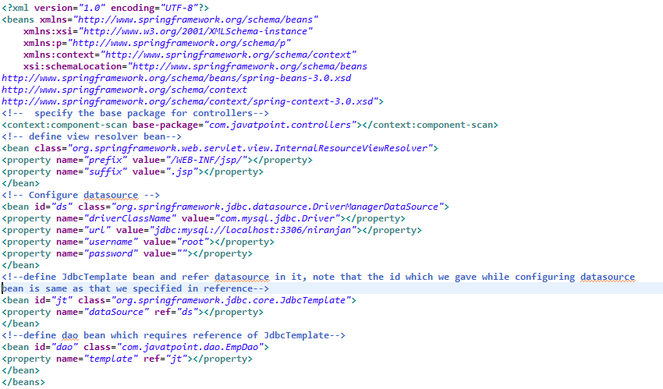

1. Create view pages in **WebContent->WEB-INF->jsp** folder

Create **empform.jsp**

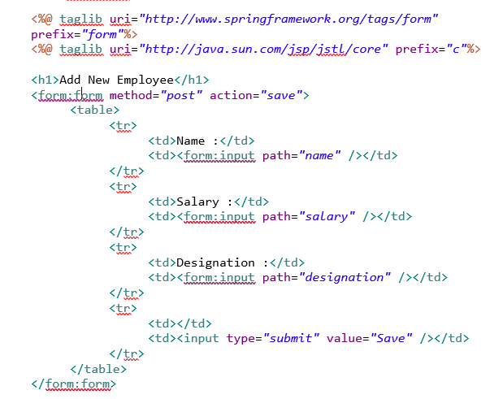

Create **empeditform.jsp**

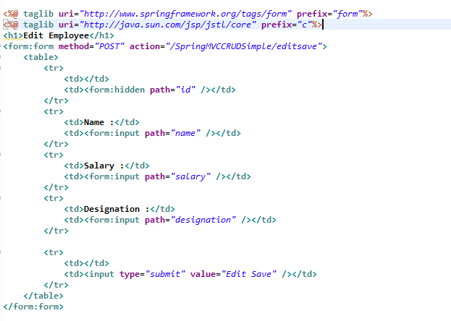

Create **viewemp.jsp**

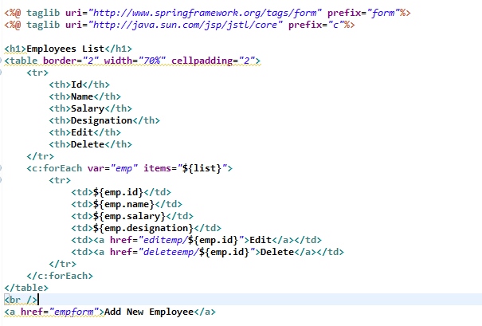

Create an index file in **WebContent** folder

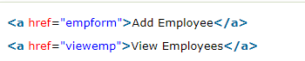

Finally before executing make sure to create table in database

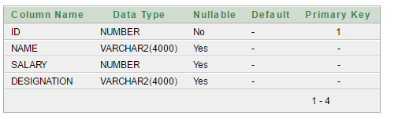

Final project structure would look like this

